Floating Structure

Subject: Physics  Related Subjects:Buoyancy | Grade Level(s):3-8  Length of Lesson: 50 minutes | Type: roject  Keywords:Density, gravity, volume, buoyant force

Lesson Overview
Buoyancy is important to understand for efficiency and safety, as engineers often analyze how floating vessels such as ships respond to weight being added to them. Students will understand the role of physics in buoyancy and further acknowledge and analyze how it helps humans in real life.

Lesson Focus
Students will use the engineering design process to design and build a structure that is able to float by using the given materials and constraints with the goal of holding as much weight as possible.

Lesson Objective(s) | By the end of this lesson, students will…  - To design and build a boat with the greatest buoyant force.  - Understand the concepts behind buoyancy.  - Apply their knowledge to real-life scenarios.

Lesson Timing

5 minutes | Introduction
25 minutes | Build and Test
15 minutes | Evaluate and Redesign
5 minutes | Discussion and Wrap-Up

Materials | Students:  - 1 meter of aluminum foil  - 4 craft sticks  - 4 toothpicks  - 2 straws  - 30 cm of tape / Glue  Instructor:  - Container with water (clear preferred and will only be used by teacher)  - Coins or small objects that will add weight while testing
Instructor Prep | - Practice lesson  - Prepare materials in advance
Related Resources | - Buoyancy: What Makes Something Float or Sink? (https://youtu.be/nMlXU97E-uQ)

Lesson Plan

Introduction
Buoyancy is the tendency of an object to float in a fluid. All liquids and gasses in the presence of gravity exert an upward force known as buoyant force on any object immersed in them. Buoyancy results from the differences in pressure acting on opposite sides of an object immersed in a static fluid.
- Due to buoyant force, also known as upthrust, a body submerged partially or fluid appears to lose its weight and/or feel lighter.
Buoyant force is affected by:
- The density of the fluid
- The volume of the fluid displaced
- The local acceleration due to gravity
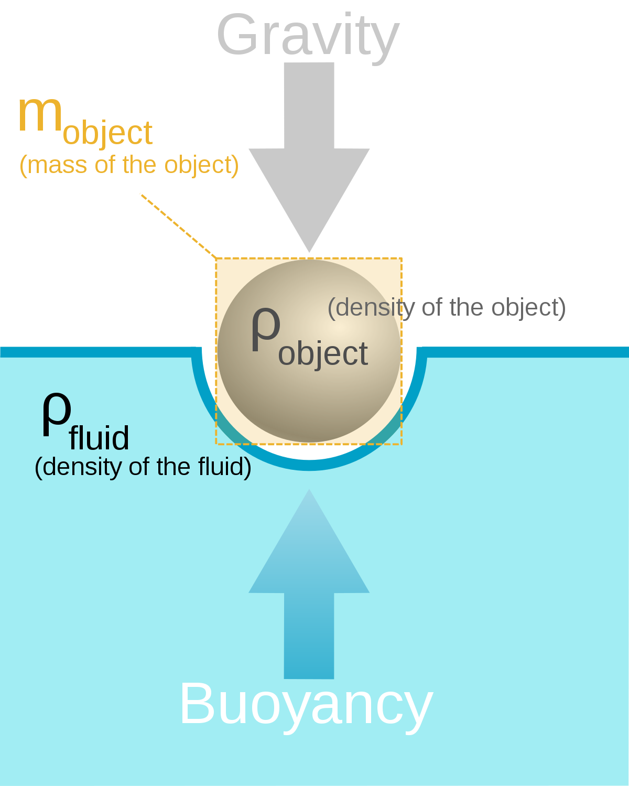

For further background information on buoyancy, instructor may show students the following video:
- Buoyancy: What Makes Something Float or Sink? (https://youtu.be/nMlXU97E-uQ)

Procedure
The goal of this project is to create a floating structure with the given materials and time that will hold the most amount of mass, as well as considering the following constraints:
- You may use only the materials listed to build your boat.
- You may omit only one item from the listed materials. All others must be included.
- Your boat may be no larger than 50 cm in any dimension.
- When testing the boats, the last mass added to the boat (the one that makes it sink) must be removed from the boat before totaling the mass that the boat held.

- Students will have 10 minutes to design and build their first prototype structure following the previous guidelines.
- Ask the students their reasoning behind their plans and why they think it will work, or what they are still questioning.
- Before starting the testing step, students should copy the following table to record their results:

 | Trial 1 | Trial 2 | Trial 3
Prototype 1
Prototype 2

The table will be helpful to keep track of how many coins the structure could carry in each trial.
- After finishing the first prototype, students will place their structure on the water to test how many coins (or objects) their structure is able to carry before sinking.
  - Students should be able to recognize the room of improvement for their structures to sustain more weight.
- Allow extra 5-7 minutes depending on the students needs to allow them to improve their prototype according to their observations.
- Test their designs once again and determine whether the adjustments were helpful, neutral, or even if they worsened their results.
  - All improvements and challenges are essential for learning and understanding STEM concepts.

Wrap-up
- After collecting all the data, discuss the following questions with the students:
  - What is a concept you understood clearly? Which one do you think was the most difficult to learn?
  - How do you think your project could be improved? Would you have done anything differently if you were given different materials, more time, or less restrictions?
  - How is buoyancy related to human society? In transportation, entertainment, or even food.
  - Why do you think it is so important for engineers to study physics and buoyancy?
- Have students help clean their area and put materials away.

Lesson Background for Teachers

Real-World STEM Connections
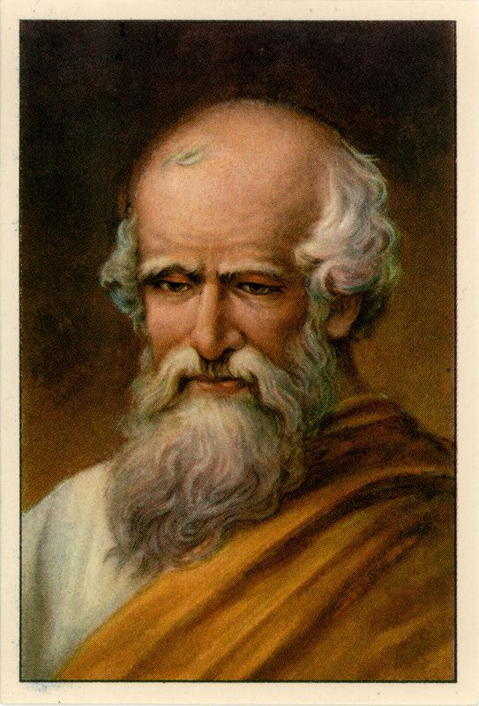
Archimedes (born c. 287 bce, Syracuse, Sicily [Italy]—died 212/211 bce, Syracuse)
- Greek mathematician, physicist, engineer, astronomer, and inventor from the ancient city of Syracuse in Sicily.
Archimedes' principle, physical law of buoyancy, states that any body completely or partially submerged in a fluid (gas or liquid) at rest is acted upon by an upward, or buoyant, force, the magnitude of which is equal to the weight of the fluid

Key Concepts and Vocabulary
- Density: Degree of consistency measured by the quantity of mass per unit volume.
- Gravity: The force that attracts a body toward the center of the earth, or toward any other physical body having mass.
- Volume: The amount of space that a substance or object occupies, or that is enclosed within a container, especially when great.
- Buoyant force: The upward force exerted by any fluid upon a body placed in it
- Buoyancy: The ability or tendency to float in water or air or some other fluid.

